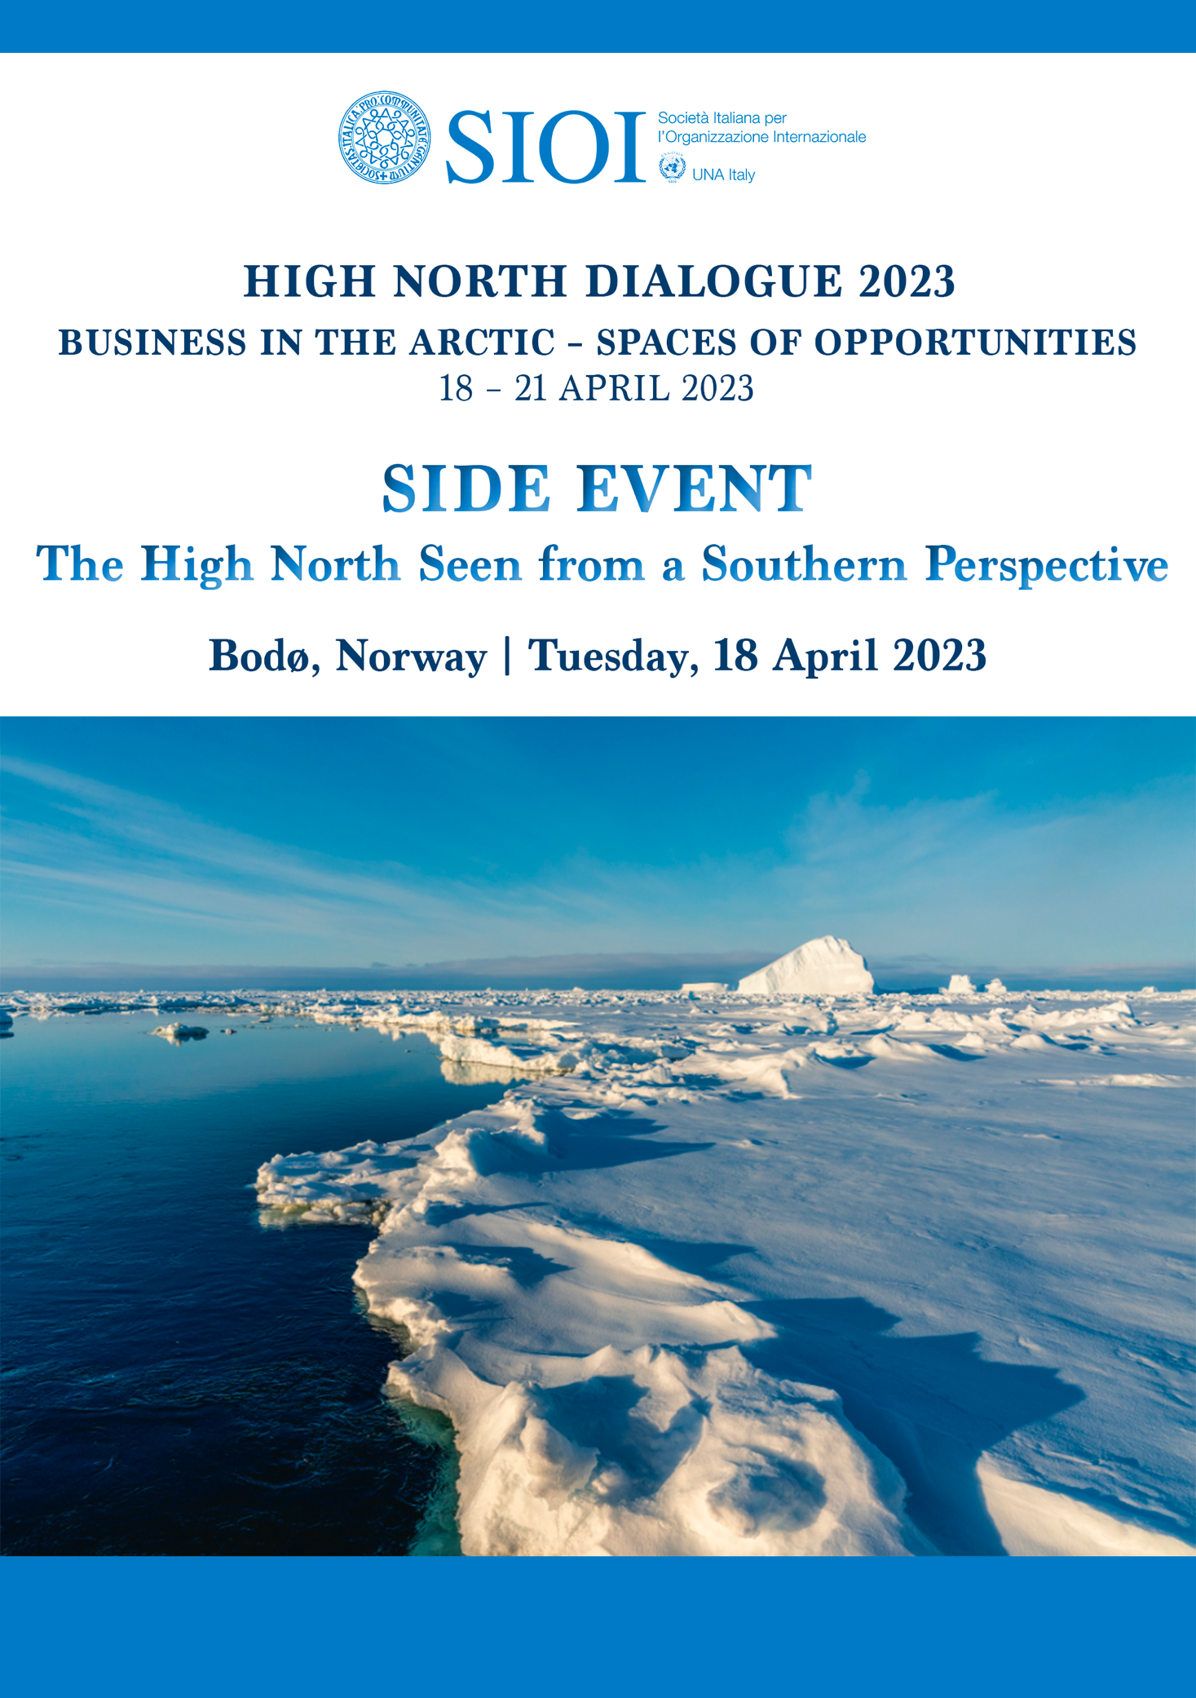

HIGH NORTH DIALOGUE 2023
Business in the Arctic – Spaces of Opportunities | 18 – 21 April 2023
HIGH NORTH CENTER
Bodø, Norway

SIDE EVENT
THE HIGH NORTH SEEN FROM A SOUTHERN PERSPECTIVE
Tuesday 18 April 2023 -11.30 AM - 12.30 PM

SIOI-UNA Italy organizes a side event on “The High North Seen from a Southern Perspective” as part of High North Dialogue 2023. This annual conference, organized by High North Center for Business and Governance at Nord University, brings together major stakeholders concerned with Arctic development. The purpose of the event is to encourage and facilitate dialogue between stakeholders to promote sustainable development in the Arctic, as well as information sharing and discussion of best practices.
Taking place in conjunction with the High North Dialogue, Side Events are an integral part of the conference.

ORGANIZER:
SIOI-UNA Italy – Italian Society for International Organization and Italian Association for the United Nations

CONTACT PERSON:
Director General – Cristina Puccia c.puccia@sioi.org
Arctic Division – Alessandra Caruso a.caruso@sioi.org

SESSION
Italy has an ultra-centennial history in the Arctic and it has been one of the most active members since joining the Arctic Council in 2013.
Norway is the Arctic country with which the greatest collaborations have been developed, in the scientific, technological and industrial fields. Being this year the main theme “Business in the Arctic – Space of Opportunities”, it is very important to confirm and to strengthen this cooperation by uniting two regions, the Arctic and the Mediterranean, that surround the same continent, through a joint and renewed partnership.
What happens in the Arctic impacts with tangible repercussions the Arctic region as well as the Mediterranean and beyond. The Arctic challenges have nowadays become global as “what happens in the Arctic does not stay in the Arctic”.
Global challenges imply global approach, request common efforts and shared responsibilities for the whole international community while respecting the sovereign rights, the ecosystem and indigenous people.

The side event has the main goal to be an open brainstorming debate to enlighten the main strengths of the partnership and the key points for an effective outreach strategy in order to contribute to the sustainable development of the Region.

PANELISTS:
Representative from the Italian Embassy in Norway (tbc) – Welcoming Address
Alessandra Caruso – Arctic Affairs Officer, SIOI-UNA Italy – Welcoming Address

Bård Borch Michalsen - UiT Norges arktiske universitet – Moderator

Carmine Robustelli – Special Envoy for the Arctic, Italian MFA
Aldo Pigoli – Professor, Catholic University of the Sacred Heart of Milan
Andreas Raspotnik - Senior Researcher, Fridtjof Nansen Institute & Senior Researcher, High North Center for Business and Governance, Nord University

TIME AND PLACE
Tuesday, 18 April 2023, 11.30 AM - 12.30 PM
Stormen Library, Litteratursalen
Storgata 1A, Bodø

CONTACTS
SIOI-UNA Italy
Palazzetto Venezia – Piazza di San Marco 51, Rome, Italy
Website: www.sioi.org - Email: relazioniesterne@sioi.org - Ph.: +39 06.6920781

